Syvecs S7Plus DQ250 Connections
The Syvecs talks to the TCM inside of the DQ250 over canbus, the custom code is designed to work with either the OEM Shifter Module fitted or without. If you are planning to use the OEM Shifter then you need to Tee the Canbus connections of the Shifter into the canbus going from the Syvecs Can Output to the TCM.
You change the setting in Scal for the Shifter in I/O Configuraton – Car Coding – Car Code 4
1 = Standalone Code with OEM Shifter fitted
2 = Standalone Code with No Shifter fitted and uses Switches as Above for Selecting Gear
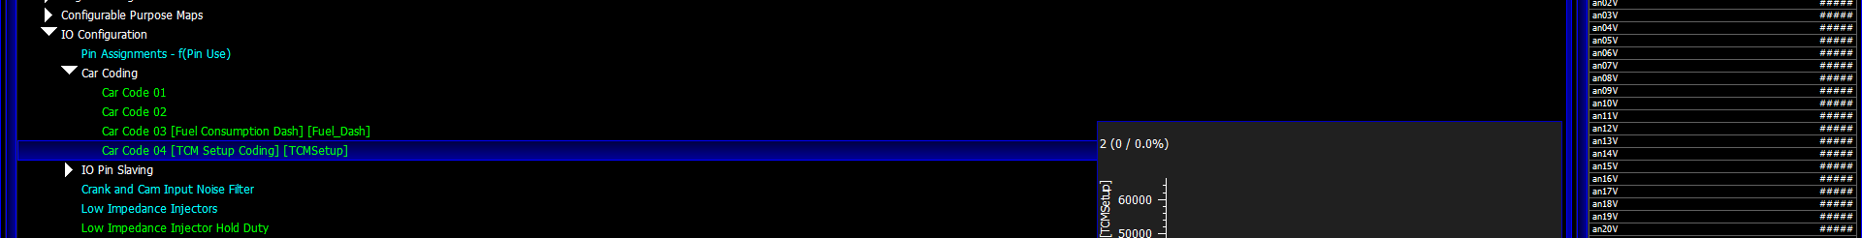
If you are not using the OEM Shifter you will need to Wire in 2x On/Off Style Switches and also 2x push to make style paddle switches.
These will be used for the following:
-Shift Up (Push to Make)
-Shift Down (Push to Make)
-Sport / Normal (On/Off Toggle)
-Manual / Auto (On/Off Toggle)
The Switches should be wired so one side goes to Ground and the other side goes to a Input on the Syvecs which has a Pull-up option like a Unipolar, Thermistor, Bipolar or AS input on the S7 Range.
Shifter connections on the ECU
If using the OEM Shifter block then you just need to wire in the Paddle up and Paddle Down signal as below.
PaddleUp signal needs to be assigned to Input U02 in Pin Assignments
PaddleDown signal needs to be assigned to Input U03 in Pin Assignments
If you wish to NOT use the OEM Shifter block then you also need to wire in two additional switches as below as well as the paddles above.
SportSwitch signal needs to be assigned to Input U04 in Pin Assignments
Manual/Auto signal needs to be assigned to Input U01 in Pin Assignments
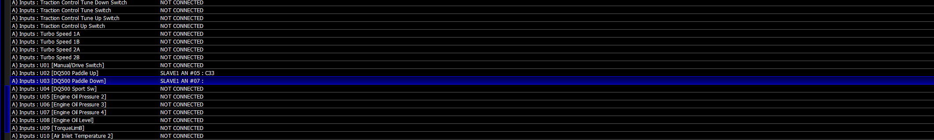
The Following items are needed also on the Syvecs Installs for the Tcm Control to work:
- 2 or more, Speed signals (The TCM needs to see Left and Right speeds of the driven axle)
- Brake Signal ( ECU Input needs to go to 5v or 12v When pressed) assigned to Brake pressure Front in Pin Assignments
These need to be wired to the Syvecs S7 ECU and setup to read correctly especially the speed scaling.
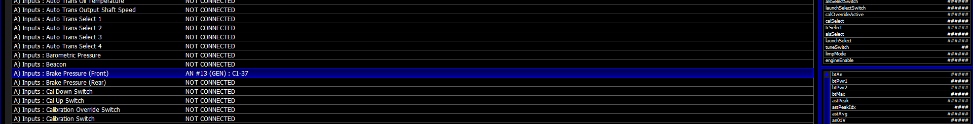
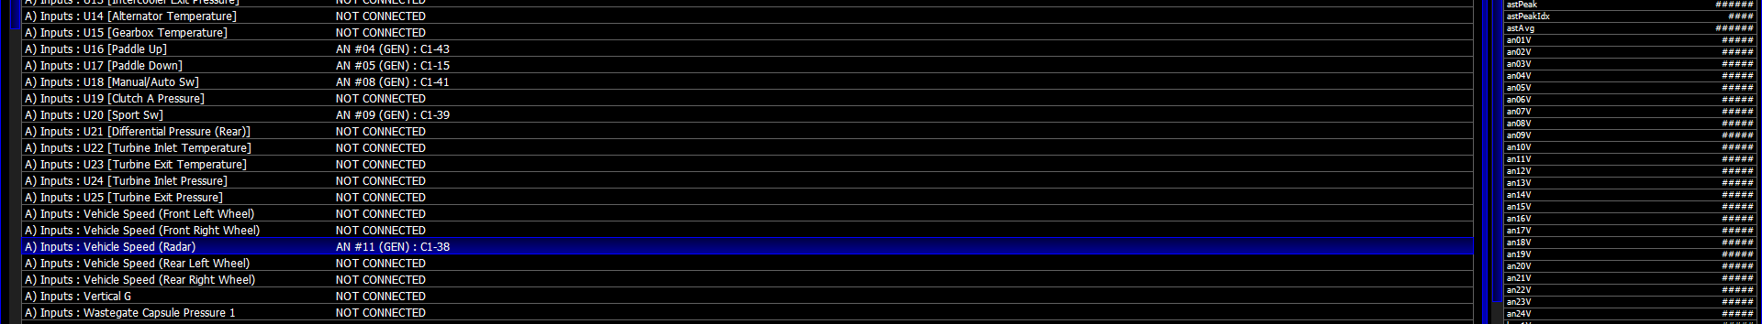
CanBus Wiring
If using an S7Plus then C8 (Can low) and C9 (Can High) are used, Can2 on B2&B3 is available for dashes or Canbus receive from ABS Modules

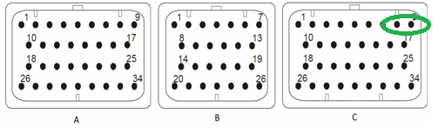
If using an S8/S12 then a can bridge will be needed and Pins 5 (Can Low) and 14 (Can high) are the wires that connect to the DQ250 Gearbox and Shifter.

The Canbus Connections from the ECU connect to the Mechatronic connector on the gearbox as shown below
Pin10 – Can High (AWG22-26 wire Gauge)
Pin11 – Ignition 12v Supply (AWG18-20 wire Gauge)
Pin13 – 12v Fused from battery (AWG16-18 wire Gauge)
Pin 15 – Can Low (AWG22-26 wire Gauge)
Pin19 – Ground (AWG16-18 wire Gauge)

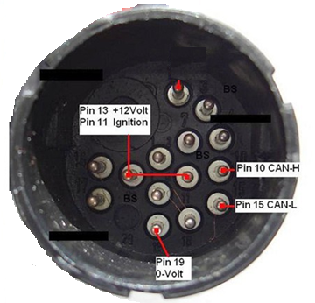

Controls of the Kit when the OEM Shifter Block is NOT fitted
When ignition is turned and engine not running the ECU will send out a Park Request if not using the OEM Shifter.
Engine running and pulling the Paddle up lever from Park/Neutral with Brake Pressed the car will either select Drive or Manual depending on Auto Manual Switch position.. If Paddle down lever is pulled when in Neutral, Speed below 3kph and Brake pressed then it will select Reverse.
If Gearbox Position is Reverse and pulling up lever with brake pressed again it will go to D or Manual depending on Auto Manual Switch. If in Reverse and Pulling both paddles together while brake pressed it will select Neutral.
If in Drive/Sport/Manual and both levers are pulled with or without brake it will Select Neutral. There is a validation time for this of 1 Second to stop accidental Neutral selection when driving.
When car is moving and Gearbox Position is Manual then the Paddle up and Down signals become the manual up and down shift requests unless both paddles are pulled for Neutral.

Car Code 6 – If it’s equal to 1, then an automatic paddle up-shift request will happen when the Engine RPM is within 100rpm of the RevCut RPM set in Scal.

